Order of Service — April 28, 2024
(5th Sunday of Easter)

Welcome/Announcements

Opening Hymn
468 I Am Content! My Jesus Ever Lives
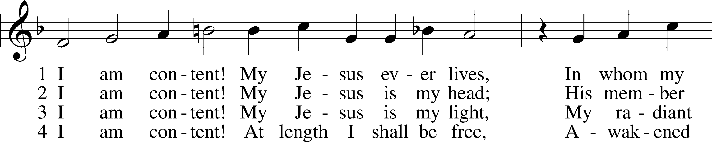
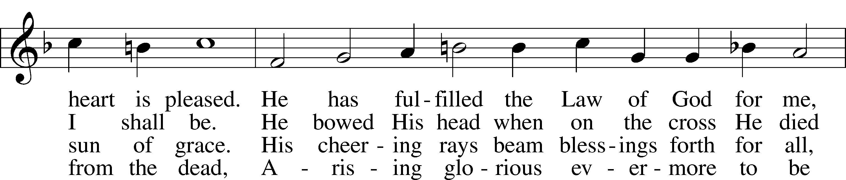
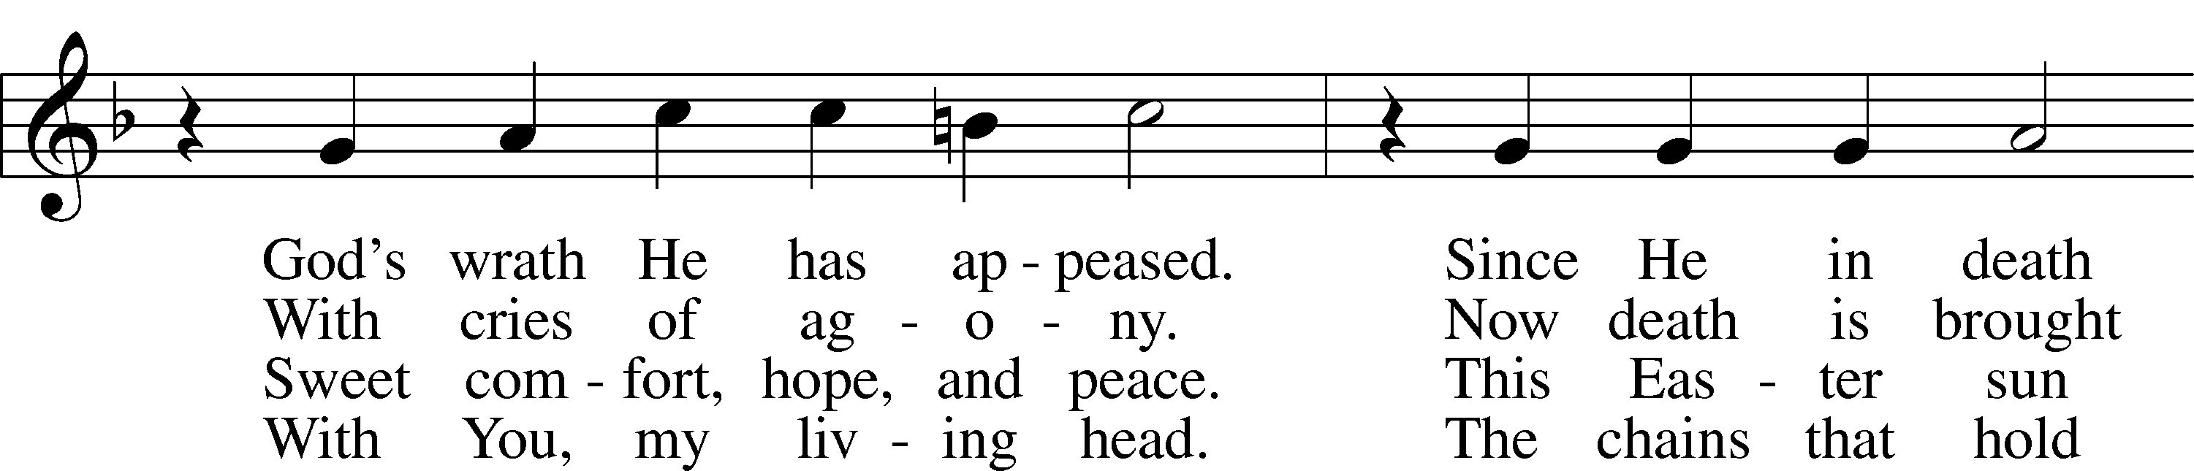
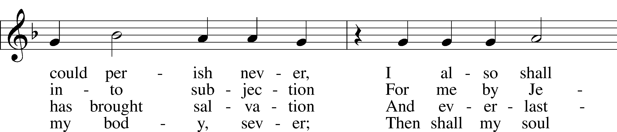
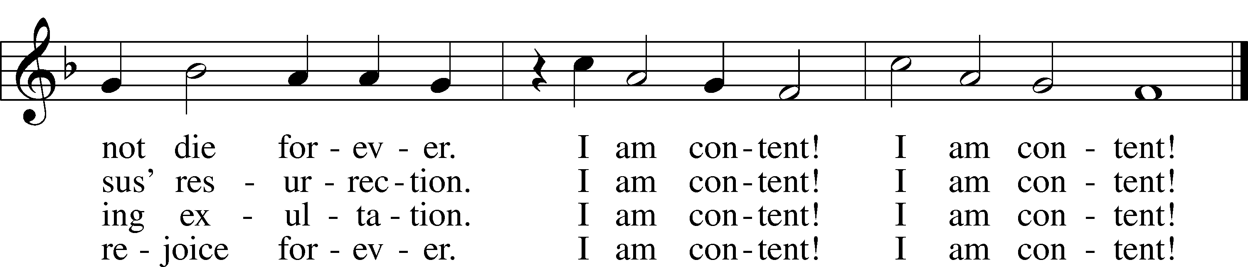
Text: attr. Johann Joachim Möller, 1660–1733; tr. August Crull, 1845–1923, alt.
Tune: Johann Rudolph Ahle, 1625–73
Text and tune: Public domain

Stand

Invocation/Confession & Absolution
P In the name of the Father and of the Son and of the Holy Spirit.
C Amen.

P Beloved in the Lord! Let us draw near with a true heart and confess our sins unto God our Father, beseeching Him in the name of our Lord Jesus Christ to grant us forgiveness.

P Our help is in the name of the Lord,
C who made heaven and earth.
P I said, I will confess my transgressions unto the Lord,
C and You forgave the iniquity of my sin.

Silence for reflection on God’s Word and for self-examination.

P O almighty God, merciful Father,
C I, a poor, miserable sinner, confess unto You all my sins and iniquities with which I have ever offended You and justly deserved Your temporal and eternal punishment. But I am heartily sorry for them and sincerely repent of them, and I pray You of Your boundless mercy and for the sake of the holy, innocent, bitter sufferings and death of Your beloved Son, Jesus Christ, to be gracious and merciful to me, a poor, sinful being.

P Upon this your confession, I, by virtue of my office, as a called and ordained servant of the Word, announce the grace of God unto all of you, and in the stead and by the command of my Lord Jesus Christ I forgive you all your sins in the name of the Father and of the Son and of the Holy Spirit.
C Amen.

Introit Psalm 145:1–2, 8, 10, 21; antiphon: John 16:16
(Jesus said): A little while, and you will see Me no longer;
and again a little while, and you will see Me.
I will extol You, my God and King,
and bless Your name forever and ever.
Every day I will bless You
and praise Your name forever and ever.
The Lord is gracious and merciful,
slow to anger and abounding in steadfast love.
All Your works shall give thanks to You, O Lord,
and all Your saints shall bless You!
My mouth will speak the praise of the Lord,
and let all flesh bless His holy name forever and ever.
Glory be to the Father and to the Son
and to the Holy Spirit;
as it was in the beginning,
is now, and will be forever. Amen.
A little while, and you will see Me no longer;
and again a little while, and you will see Me.

Kyrie LSB 186
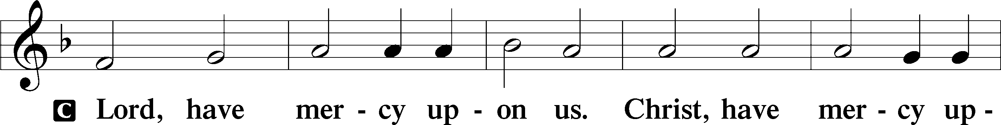
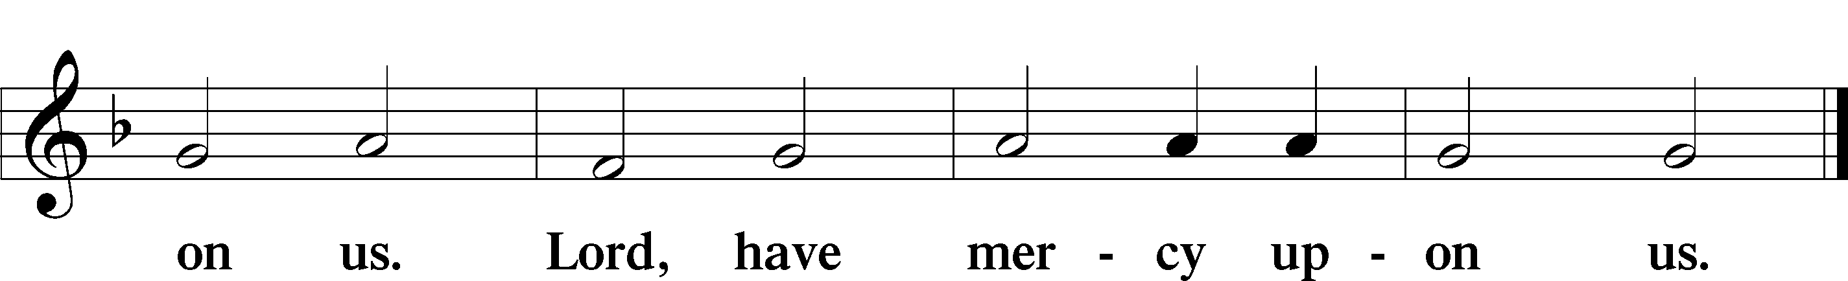

Gloria in Excelsis LSB 187
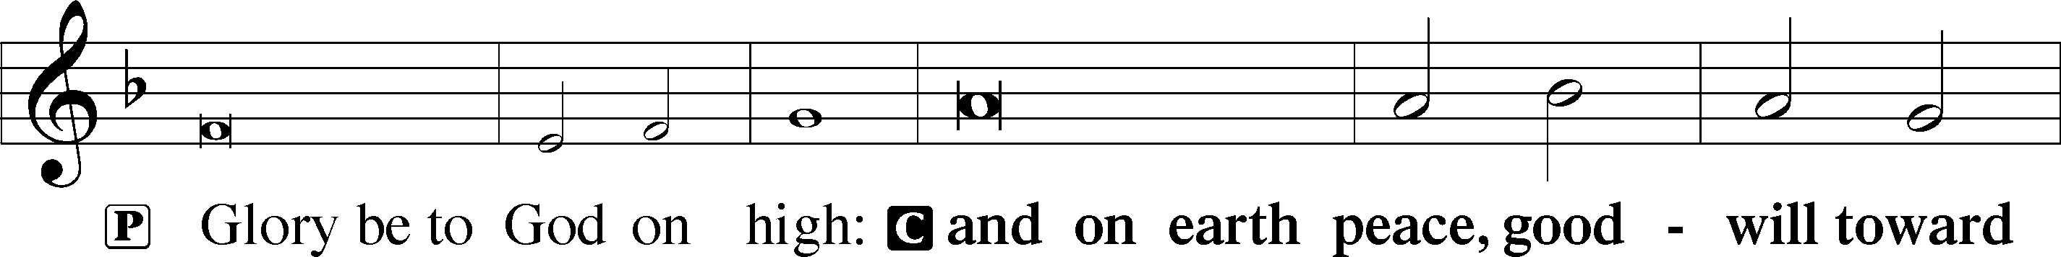
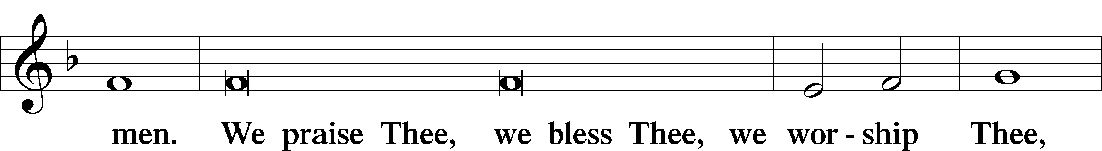
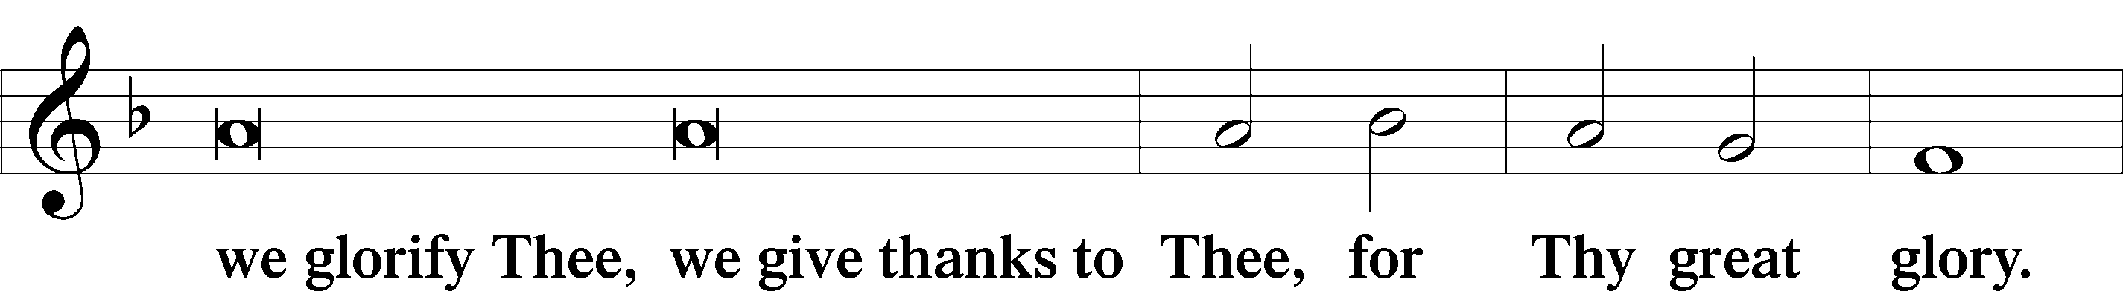
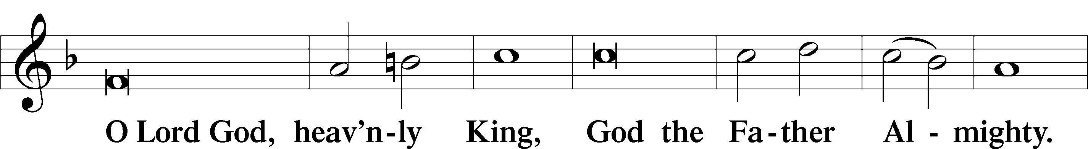
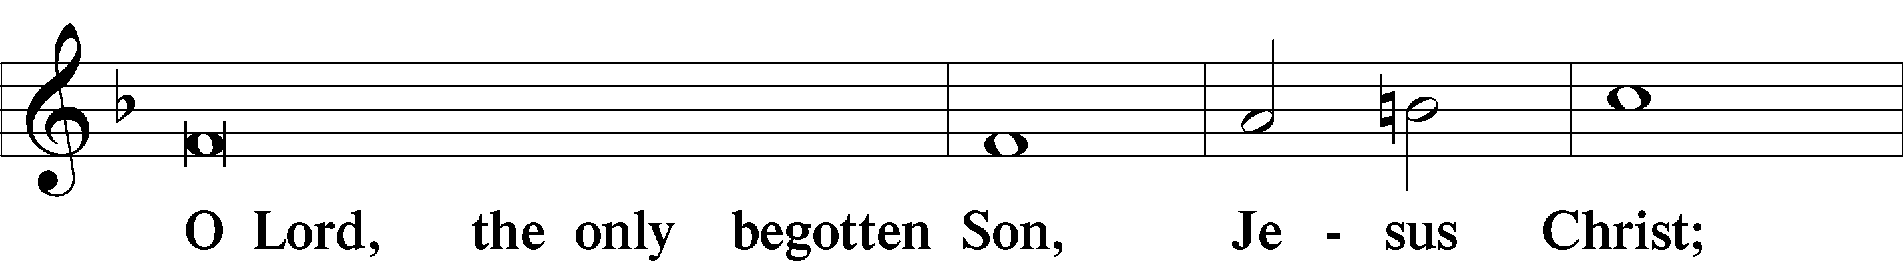
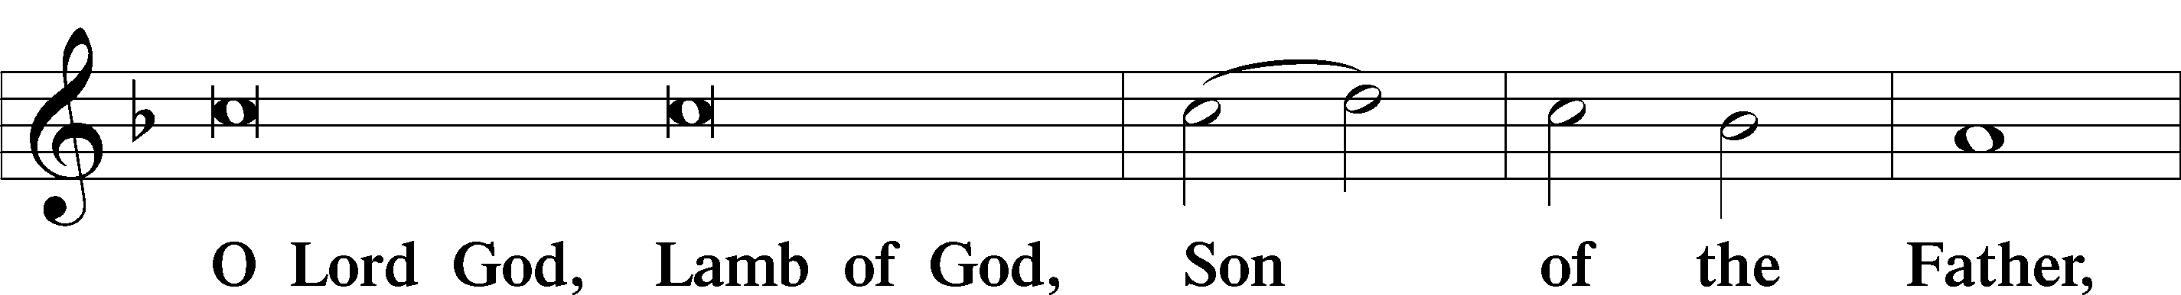
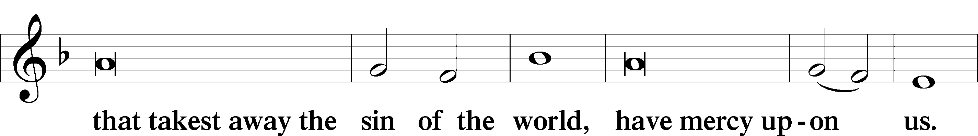
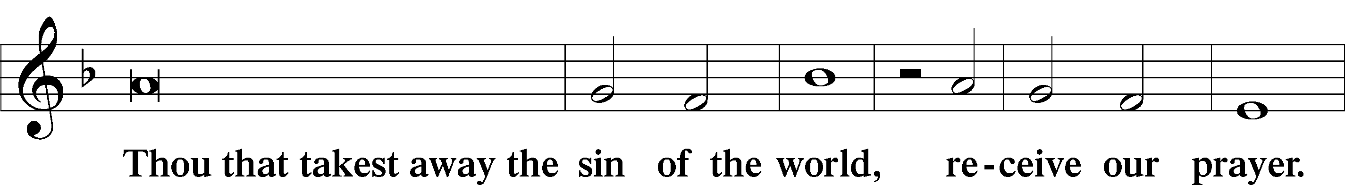
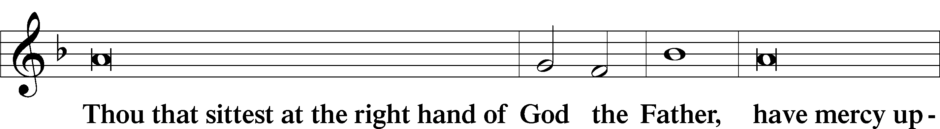
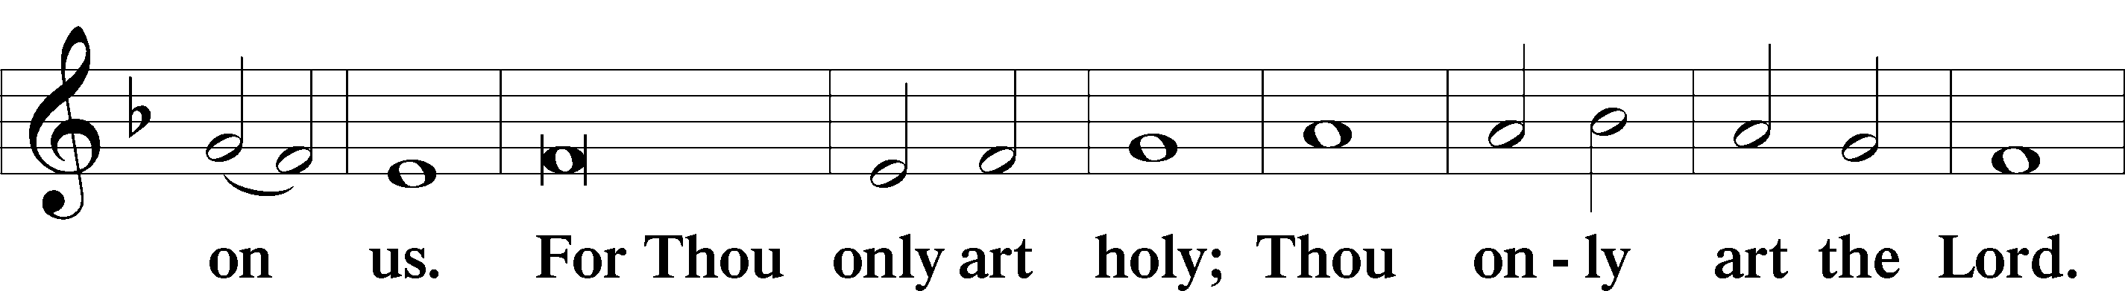
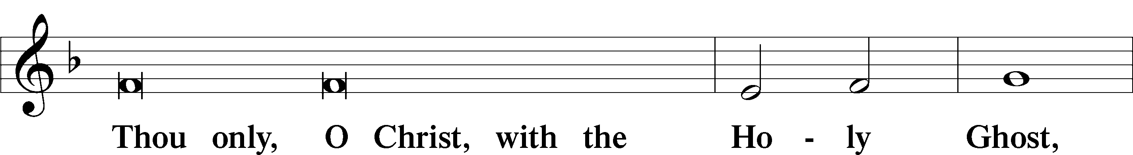
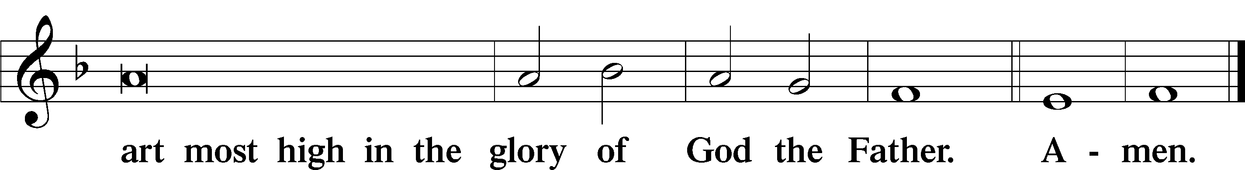

Salutation and Collect of the Day
P The Lord be with you.
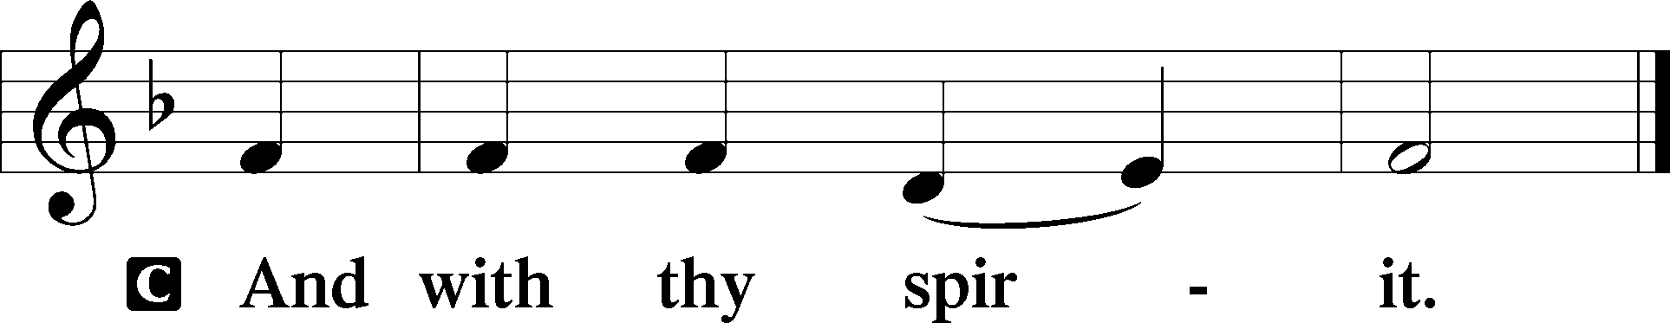

P Let us pray.
O God, You make the minds of Your faithful to be of one will. Grant that we may love what You have commanded and desire what You promise, that among the many changes of this world our hearts may be fixed where true joys are found; through Jesus Christ, Your Son, our Lord, who lives and reigns with You and the Holy Spirit, one God, now and forever.

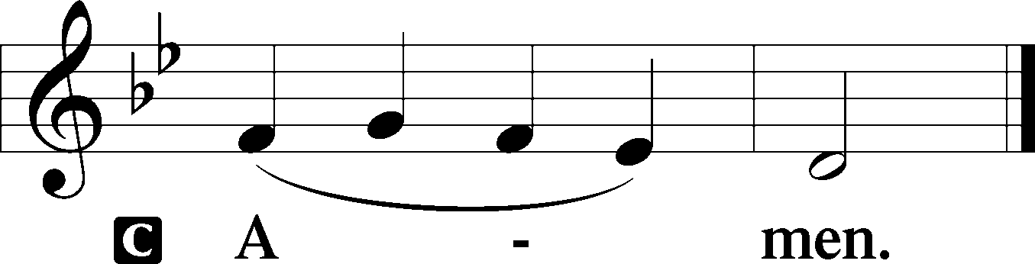

Sit

First Reading Acts 8:26–40
²⁶An angel of the Lord said to Philip, “Rise and go toward the south to the road that goes down from Jerusalem to Gaza.” Now, this is a desert place. ²⁷So, he rose and went. And there was an Ethiopian — a eunuch — a court official of Candace, queen of the Ethiopians, who was in charge of all her treasure. He had come to Jerusalem to worship ²⁸and was returning, seated in his chariot, and he was reading the prophet Isaiah. ²⁹And the Spirit said to Philip, “Go over and join this chariot.” ³⁰So Philip ran to him and heard him reading Isaiah the prophet and asked, “Do you understand what you are reading?” ³¹And he said, “How can I, unless someone guides me?” And he invited Philip to come up and sit with him. ³²Now the passage of the Scripture that he was reading was this: “Like a sheep He was led to the slaughter and like a lamb before its shearer is silent, so He opens not His mouth. ³³In His humiliation justice was denied Him. Who can describe His generation? For His life is taken away from the earth.” ³⁴And the eunuch said to Philip, “About whom, I ask you, does the prophet say this — about himself or about someone else?” ³⁵Then Philip opened his mouth, and beginning with this Scripture he told him the Good News about Jesus. ³⁶And as they were going along the road they came to some water, and the eunuch said, “See, here is water! What prevents me from being baptized?” ³⁸And he commanded the chariot to stop, and they both went down into the water, Philip and the eunuch, and he baptized him. ³⁹And when they came up out of the water, the Spirit of the Lord carried Philip away, and the eunuch saw him no more, and went on his way rejoicing. ⁴⁰But Philip found himself at Azotus, and as he passed through he preached the Gospel to all the towns until he came to Caesarea.

A This is the Word of the Lord.
C Thanks be to God.

Epistle 1 John 4:1–21
¹Beloved, do not believe every spirit, but test the spirits to see whether they are from God, for many false prophets have gone out into the world. ²By this you know the Spirit of God: every spirit that confesses that Jesus Christ has come in the flesh is from God, ³and every spirit that does not confess Jesus is not from God. This is the spirit of the antichrist, which you heard was coming and now is in the world already. ⁴Little children, you are from God and have overcome them, for He who is in you is greater than he who is in the world. ⁵They are from the world; therefore they speak from the world, and the world listens to them. ⁶We are from God. Whoever knows God listens to us; whoever is not from God does not listen to us. By this we know the Spirit of Truth and the spirit of error. ⁷Beloved, let us love one another, for love is from God, and whoever loves has been born of God and knows God. ⁸Anyone who does not love does not know God, because God is love. ⁹In this the love of God was made manifest among us: that God sent His only Son into the world, so that we might live through Him. ¹⁰In this is love — not that we have loved God but that He loved us and sent His Son to be the propitiation for our sins. ¹¹Beloved, if God so loved us, we also ought to love one another. ¹²No one has ever seen God; if we love one another, God abides in us and His love is perfected in us. ¹³By this we know that we abide in Him and He in us, because He has given us of His Spirit. ¹⁴And we have seen and testify that the Father has sent His Son to be the Savior of the world. ¹⁵Whoever confesses that Jesus is the Son of God, God abides in him, and he in God. ¹⁶So we have come to know and to believe the love that God has for us. God is love, and whoever abides in love abides in God, and God abides in him. ¹⁷By this is love perfected with us, so that we may have confidence for the day of judgment, because as He is so also are we in this world. ¹⁸There is no fear in love, but perfect love casts out fear. For fear has to do with punishment, and whoever fears has not been perfected in love. ¹⁹We love because He first loved us. ²⁰If anyone says, “I love God,” and yet hates his brother, he is a liar; for he who does not love his brother (whom he has seen) cannot love God (whom he has not seen). ²¹And this commandment we have from Him: whoever loves God must also love his brother.

A This is the Word of the Lord.
C Thanks be to God.

Stand

Alleluia LSB 190
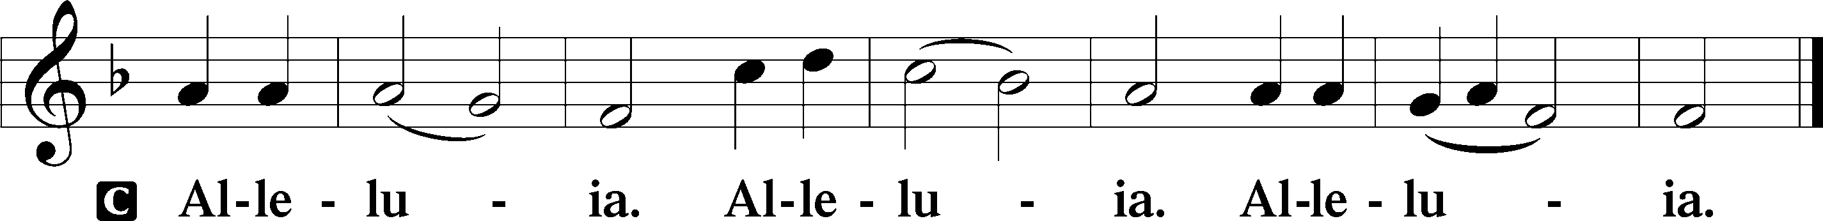

Holy Gospel John 15:1–8
P The Holy Gospel according to St. John, the fifteenth chapter.

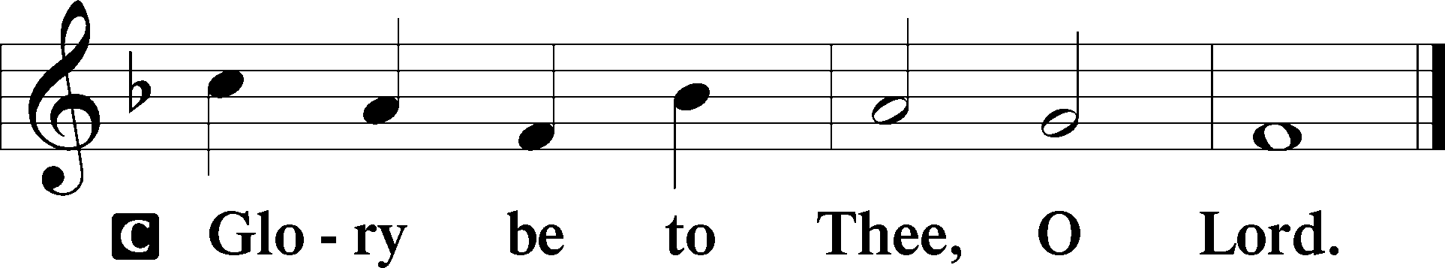

¹[Jesus said:] “I am the true Vine, and My Father is the vinedresser. ²Every branch of Mine that does not bear fruit He takes away, and every branch that does bear fruit He prunes, so that it may bear more fruit. ³You are already clean because of the Word that I have spoken to you. ⁴Abide in Me, and I in you. As the branch cannot bear fruit by itself — unless it abides in the vine — neither can you, unless you abide in Me. ⁵I am the Vine; you are the branches. Whoever abides in Me and I in him, he it is that bears much fruit, for apart from Me you can do nothing. ⁶If anyone does not abide in Me he is thrown away like a branch and withers; and the branches are gathered, thrown into the fire, and burned. ⁷If you abide in Me, and My words abide in you, ask whatever you wish, and it will be done for you. ⁸By this My Father is glorified: that you bear much fruit and so prove to be My disciples.”

P This is the Gospel of the Lord.

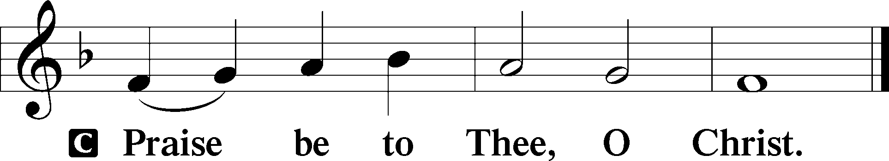

Nicene Creed
C I believe in one God,
the Father Almighty,
Maker of heaven and earth
and of all things visible and invisible.

And in one Lord Jesus Christ,
the Only-Begotten Son of God,
begotten of His Father before all worlds,
God of God, Light of Light,
Very God of Very God,
begotten, not made,
being of one substance with the Father,
by whom all things were made;
who for us men and for our salvation came down from heaven
and was incarnate by the Holy Spirit of the virgin Mary
and was made man;
and was crucified also for us under Pontius Pilate.
He suffered and was buried.
And the third day He rose again according to the Scriptures
and ascended into heaven
and sits at the right hand of the Father.
And He will come again with glory to judge both the living and the dead,
whose kingdom will have no end.

And I believe in the Holy Spirit,
the Lord and Giver of life,
who proceeds from the Father and the Son,
who with the Father and the Son together is worshiped and glorified,
who spoke by the prophets.
And I believe in one holy Christian and apostolic Church,
I acknowledge one Baptism for the remission of sins,
and I look for the resurrection of the dead
and the life of the world to come. Amen.

Sit

Sermon Hymn
487 Come, You Faithful, Raise the Strain
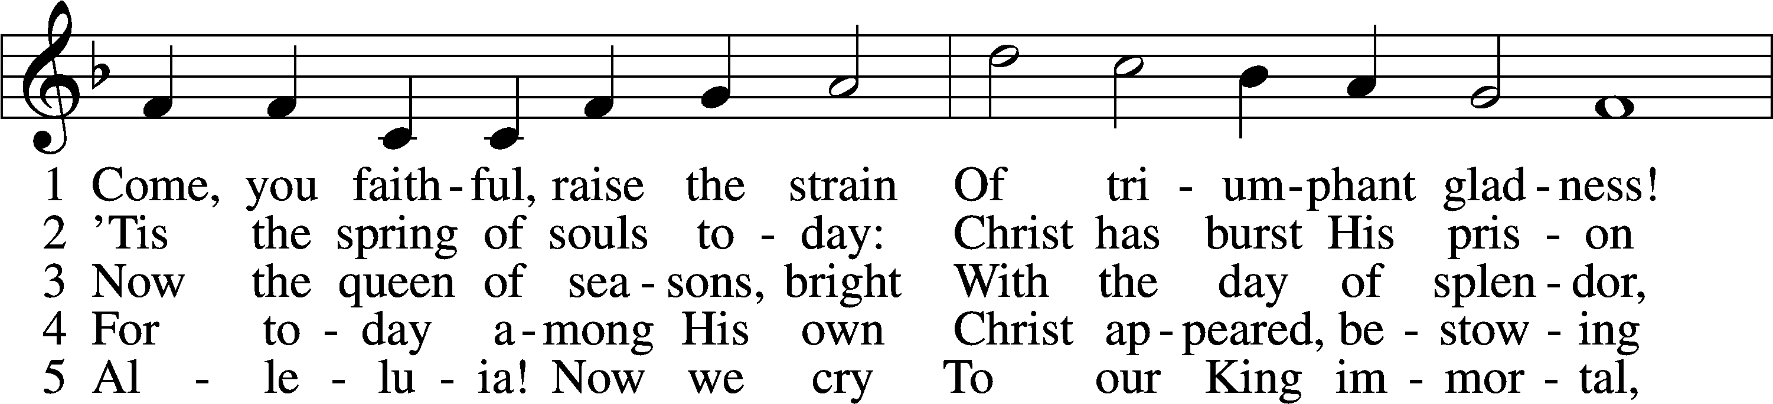
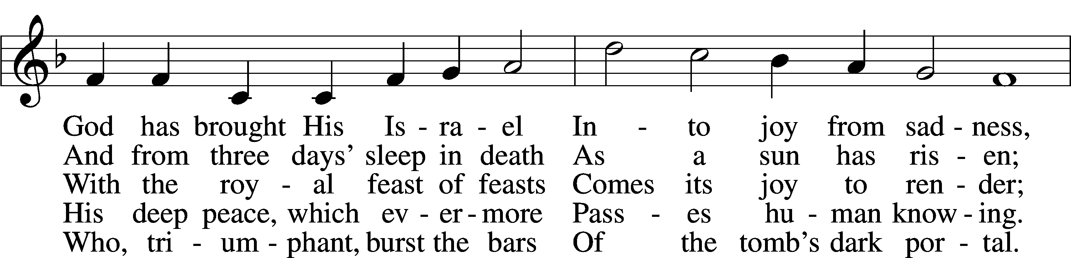
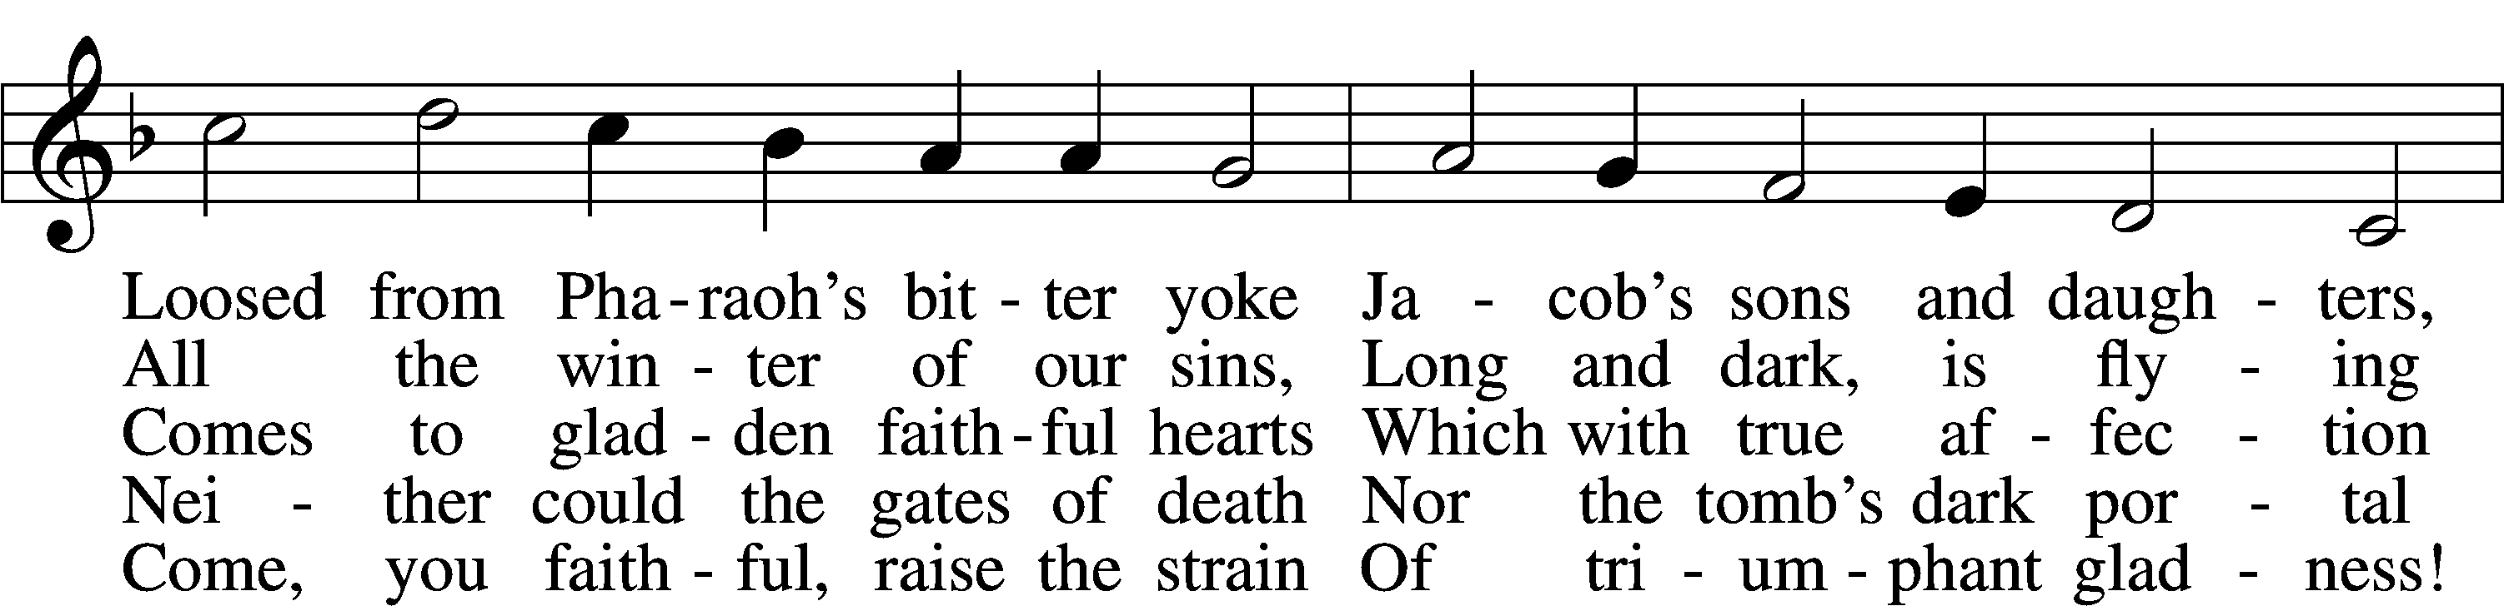
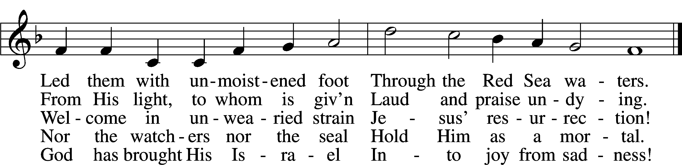
Text: John of Damascus, c. 696–c. 754; tr. John Mason Neale, 1818–66, alt.
Tune: Johann Horn, c. 1490–1547
Text and tune: Public domain

Sermon

Stand

Offertory LSB 192
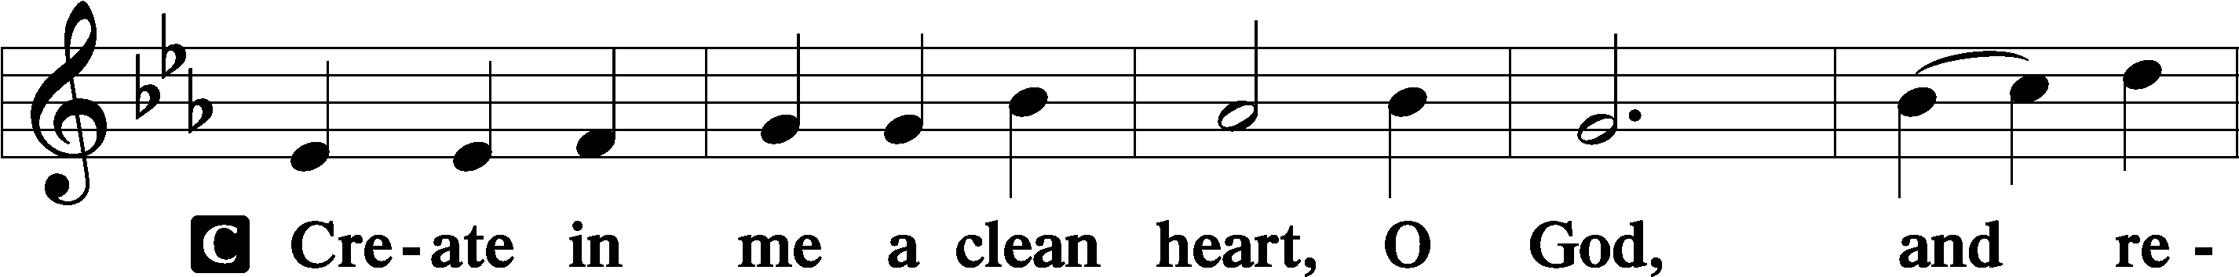
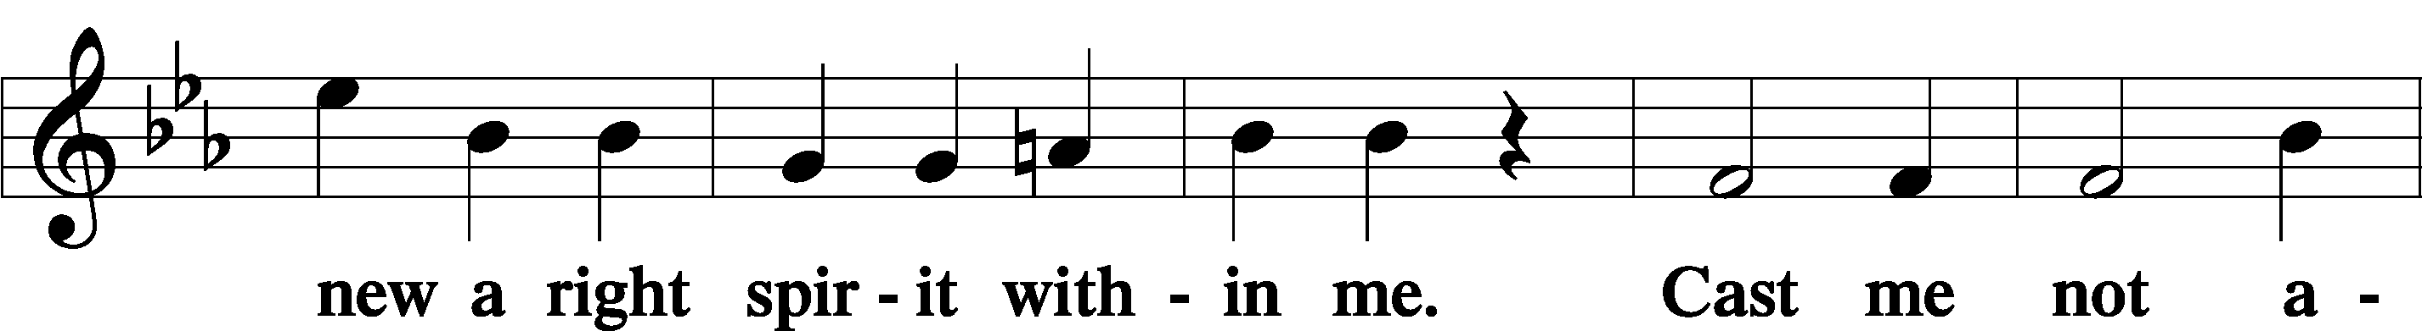
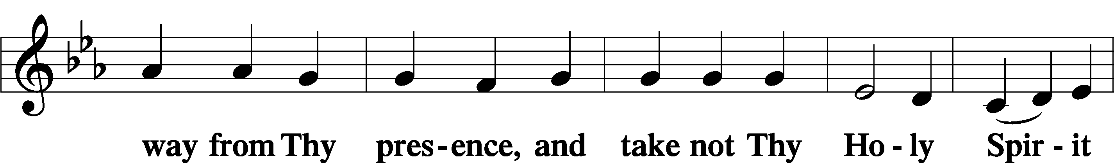
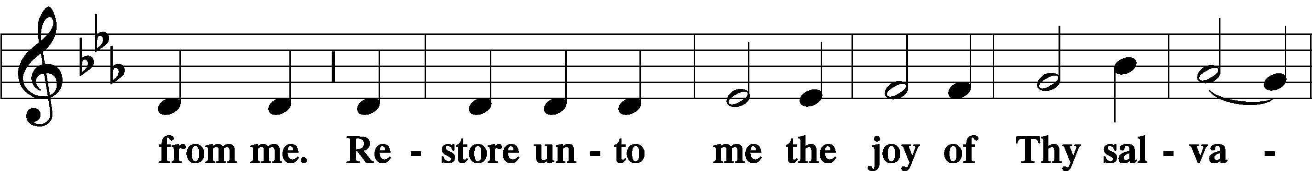
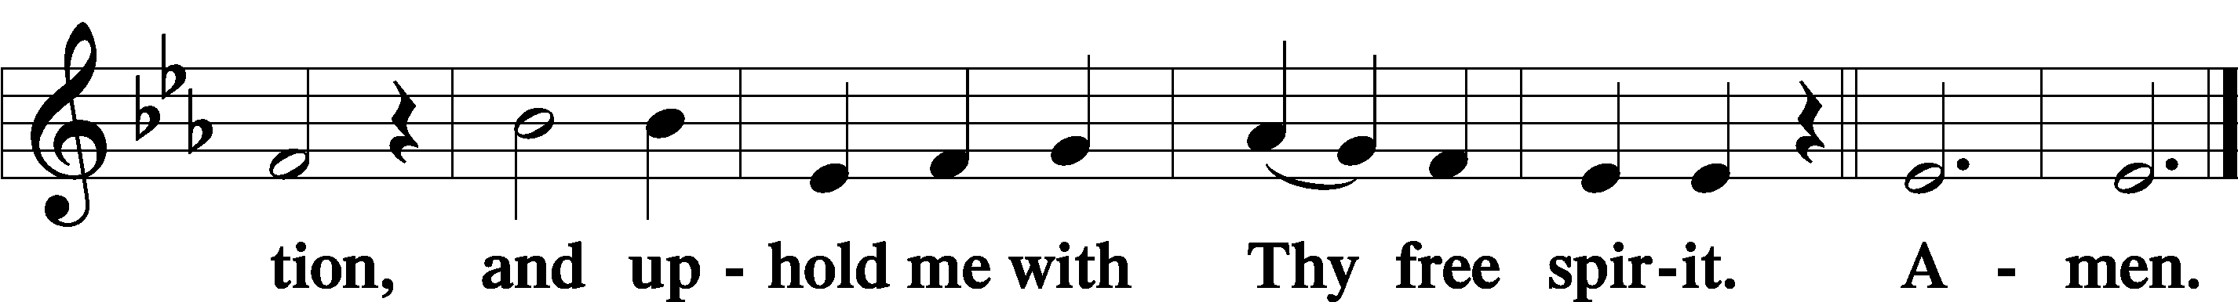

Sit

Offering

Stand

Prayer of the Church

Preface LSB 194
P The Lord be with you.
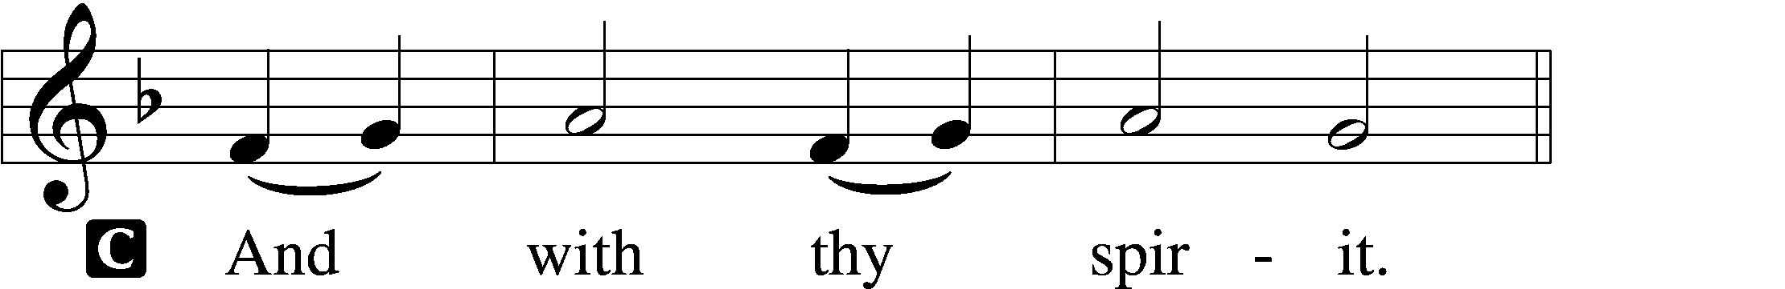

P Lift up your hearts.
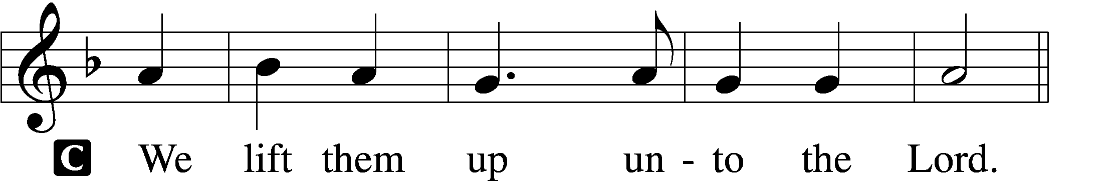

P Let us give thanks unto the Lord, our God.
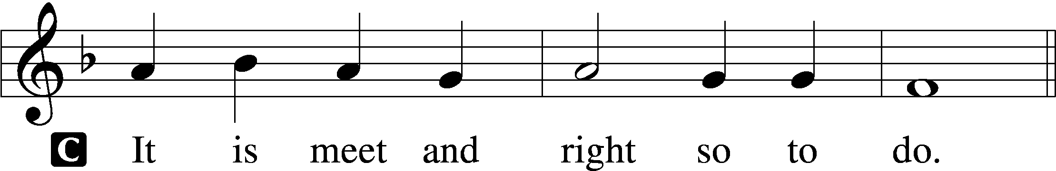

P It is truly meet, right, and salutary that we should at all times and in all places give thanks to You, holy Lord, almighty Father, everlasting God. And most especially are we bound to praise You for the glorious resurrection of Your Son, Jesus Christ, who was sacrificed for us and carried the sins of the world. By His dying He has destroyed death, and by His rising again He has restored to us everlasting life. Therefore, with angels and archangels and with all the company of heaven we laud and magnify Your glorious name, evermore praising You and saying:

Sanctus LSB 195
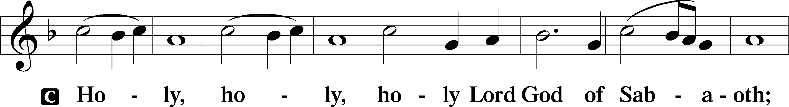
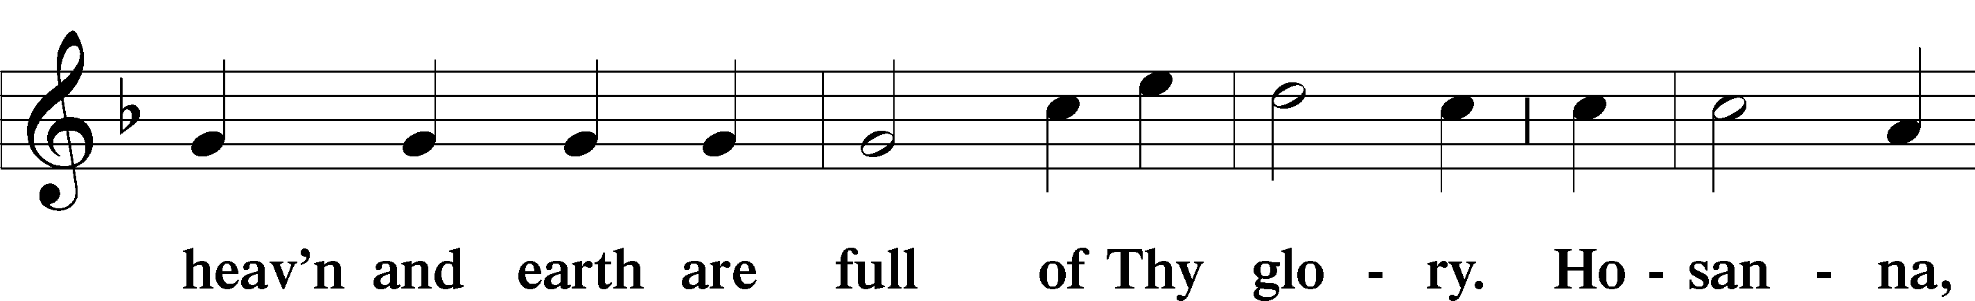
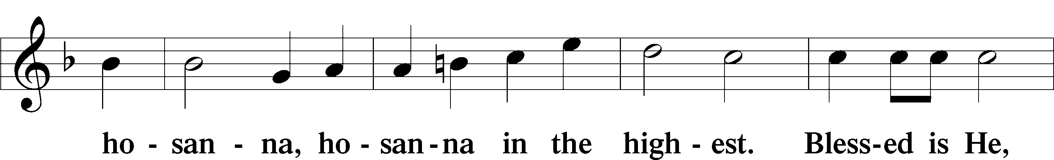
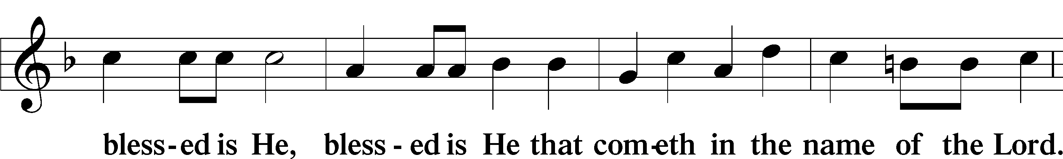
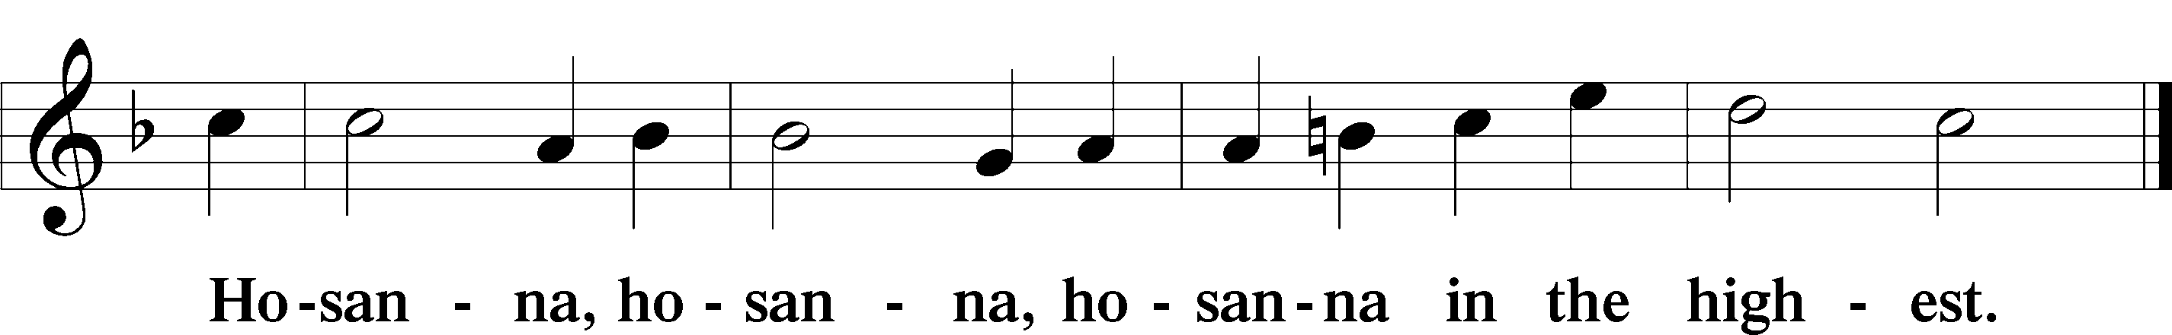

Lord’s Prayer LSB 196
P Our Father who art in heaven,
hallowed be Thy name,
Thy kingdom come,
Thy will be done on earth as it is in heaven;
give us this day our daily bread;
and forgive us our trespasses as we forgive those who trespass against us;
and lead us not into temptation,
but deliver us from evil.
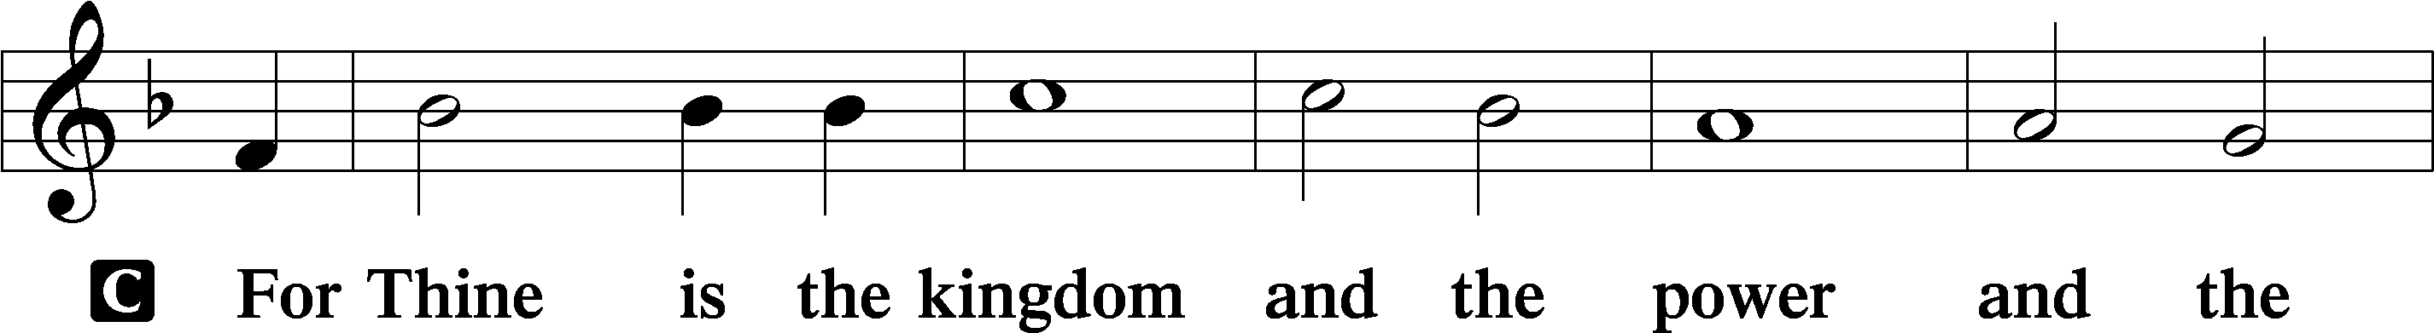
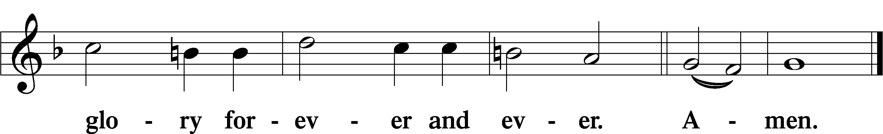

The Words of Our Lord LSB 197
P Our Lord Jesus Christ, on the night when He was betrayed, took bread, and when He had given thanks, He broke it and gave it to the disciples and said: “Take, eat; this is My body, which is given for you. This do in remembrance of Me.”

In the same way also He took the cup after supper, and when He had given thanks, He gave it to them, saying: “Drink of it, all of you; this cup is the new testament in My blood, which is shed for you for the forgiveness of sins. This do, as often as you drink it, in remembrance of Me.”

Pax Domini LSB 197
P The peace of the Lord be with you always.

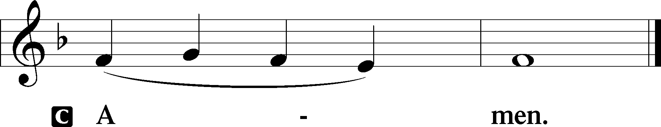

Agnus Dei LSB 198
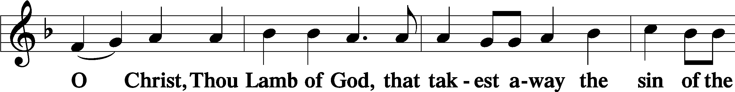
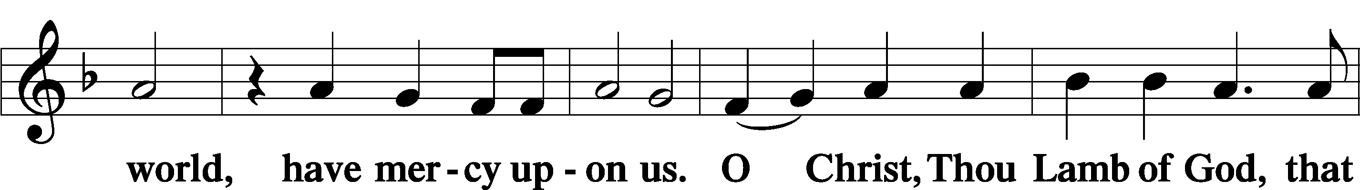
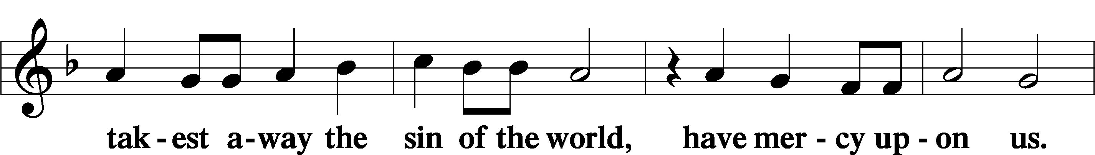
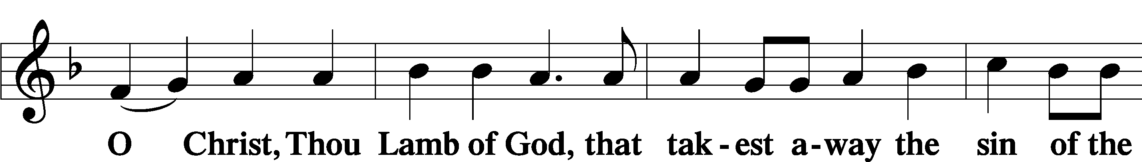
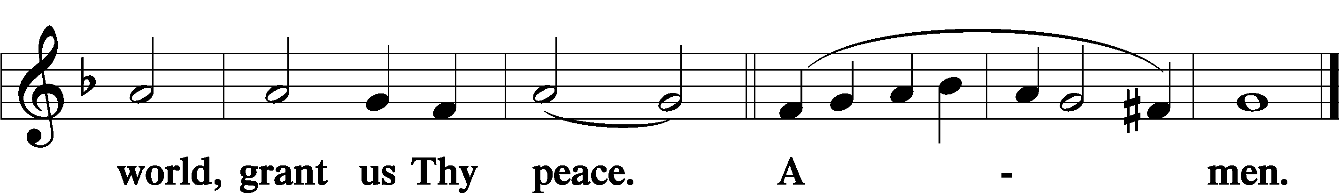

Sit

— The Distribution —

Distribution Hymn
458 Christ Jesus Lay in Death’s Strong Bands
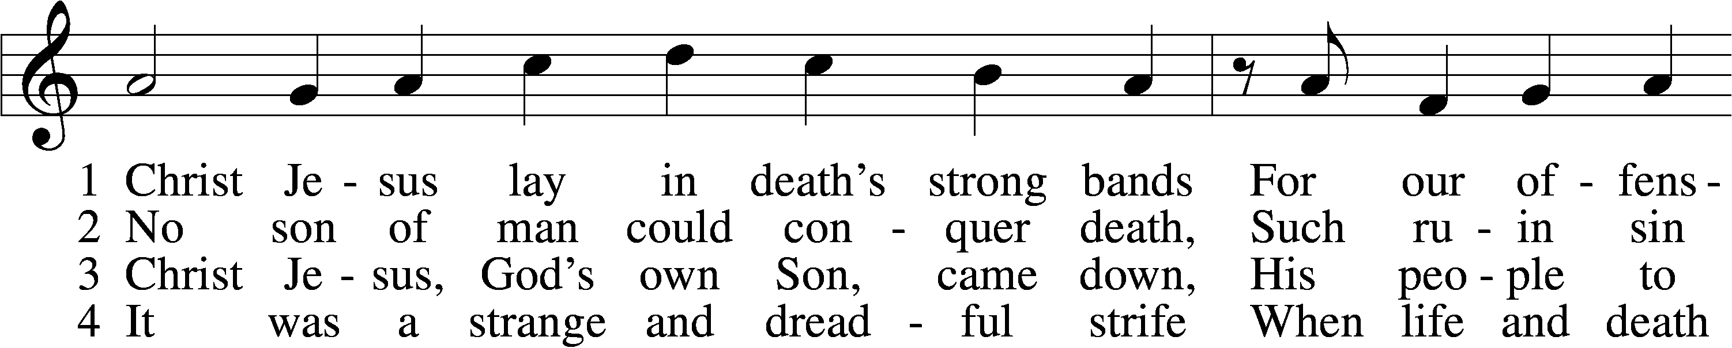
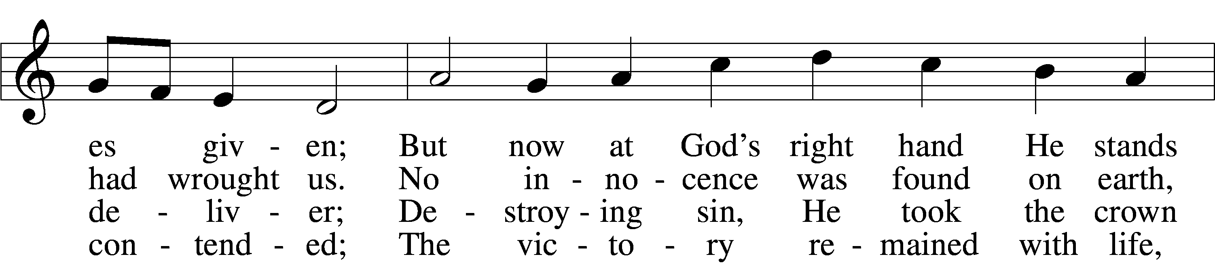
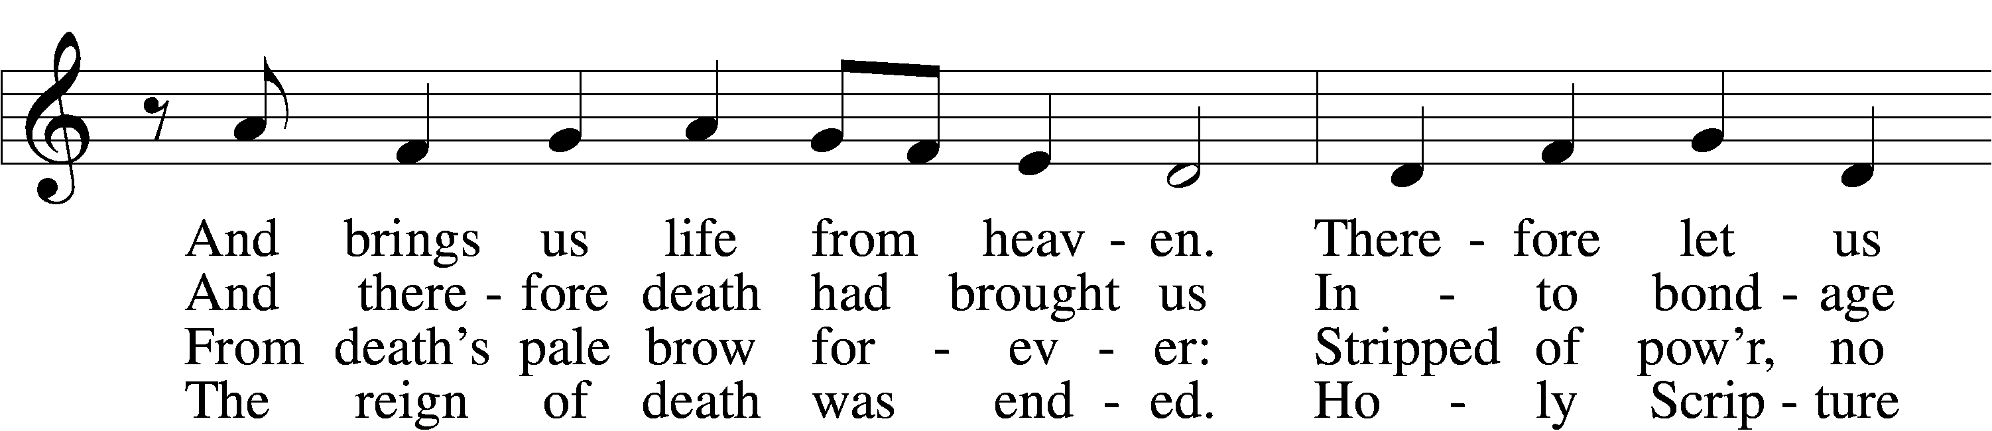
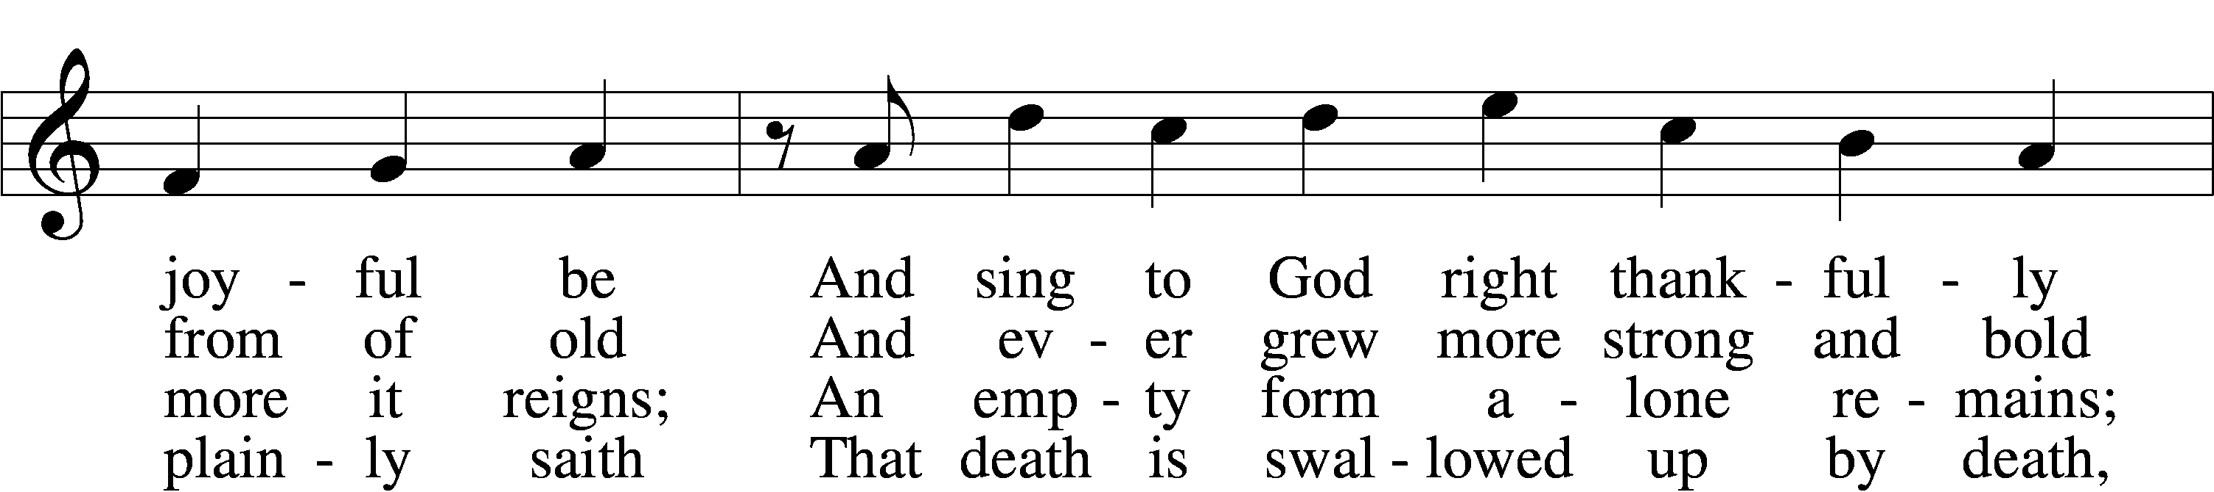
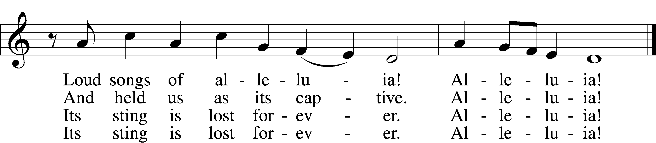

5 Here our true Paschal Lamb we see,
Whom God so freely gave us;
He died on the accursèd tree—
So strong His love—to save us.
See, His blood now marks our door;
Faith points to it; death passes o’er,
And Satan cannot harm us.
Alleluia!

6 So let us keep the festival
To which the Lord invites us;
Christ is Himself the joy of all,
The sun that warms and lights us.
Now His grace to us imparts
Eternal sunshine to our hearts;
The night of sin is ended.
Alleluia!

7 Then let us feast this Easter Day
On Christ, the bread of heaven;
The Word of grace has purged away
The old and evil leaven.
Christ alone our souls will feed;
He is our meat and drink indeed;
Faith lives upon no other!
Alleluia!
Text: Martin Luther, 1483–1546; tr. Richard Massie, 1800–87, alt.
Tune: Geystliche gesangk Buchleyn, 1524, Wittenberg, ed. Johann Walter
Text and tune: Public domain

Stand

Nunc Dimittis LSB 199
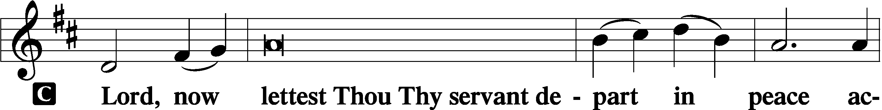

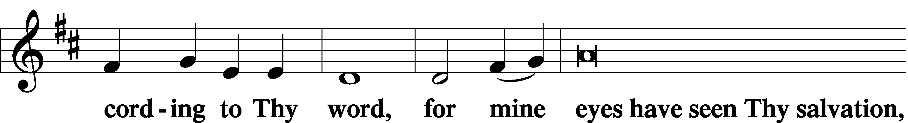

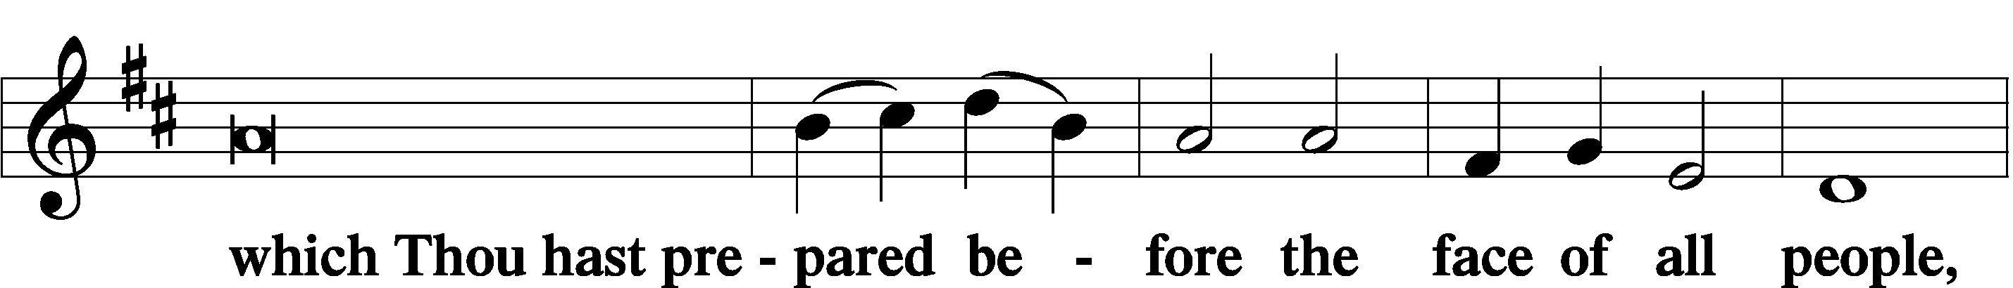

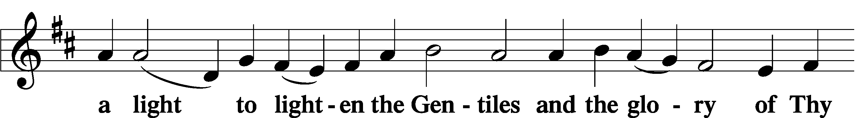

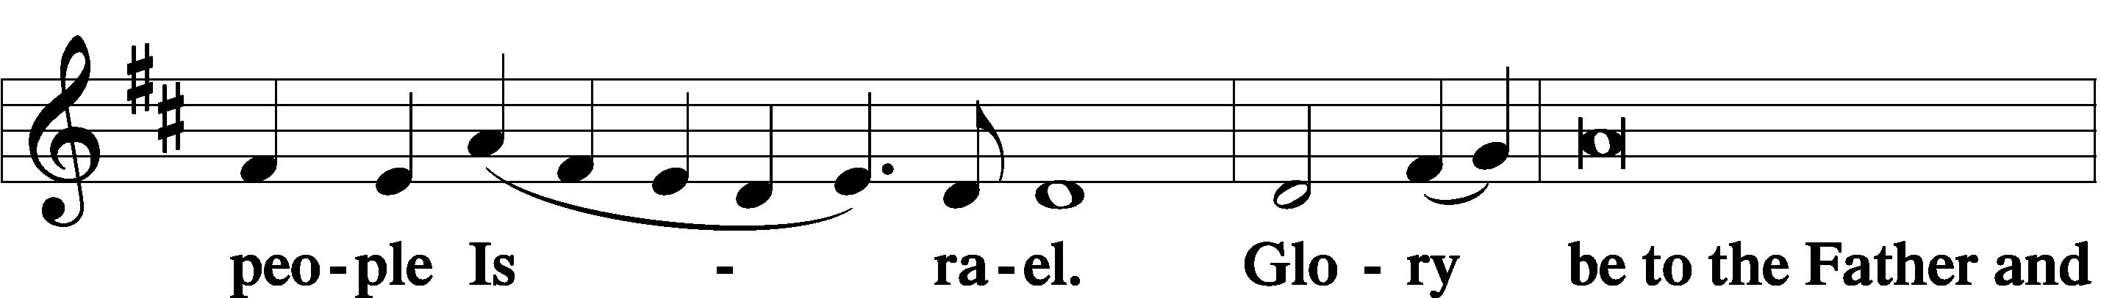

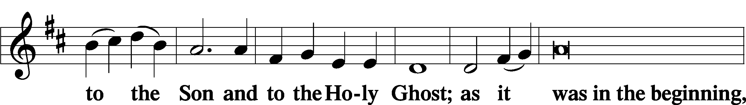

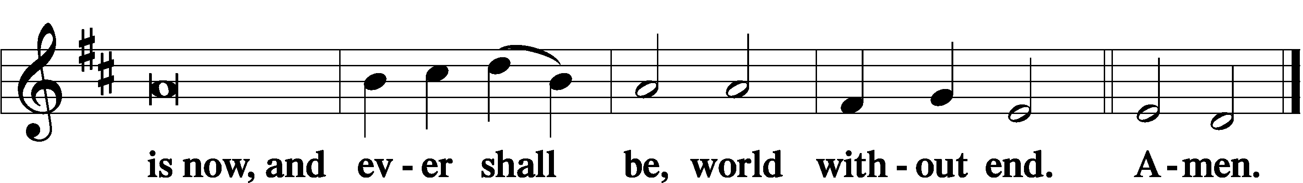

Thanksgiving LSB 200
A O give thanks unto the Lord, for He is good,

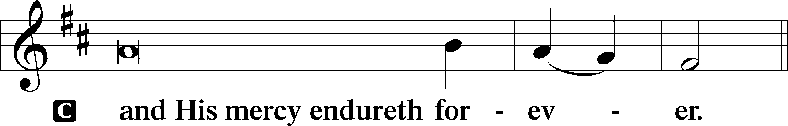

A Let us pray.
O God the Father, the fountain and source of all goodness, who in loving-kindness sent Your only-begotten Son into the flesh, we thank You that for His sake You have given us pardon and peace in this Sacrament, and we ask You not to forsake Your children but always to rule our hearts and minds by Your Holy Spirit that we may be enabled constantly to serve You; through Jesus Christ, Your Son, our Lord, who lives and reigns with You and the Holy Spirit, one God, now and forever.

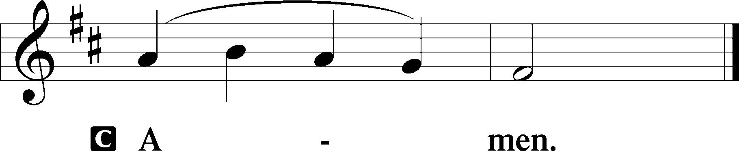

P The Lord be with you.

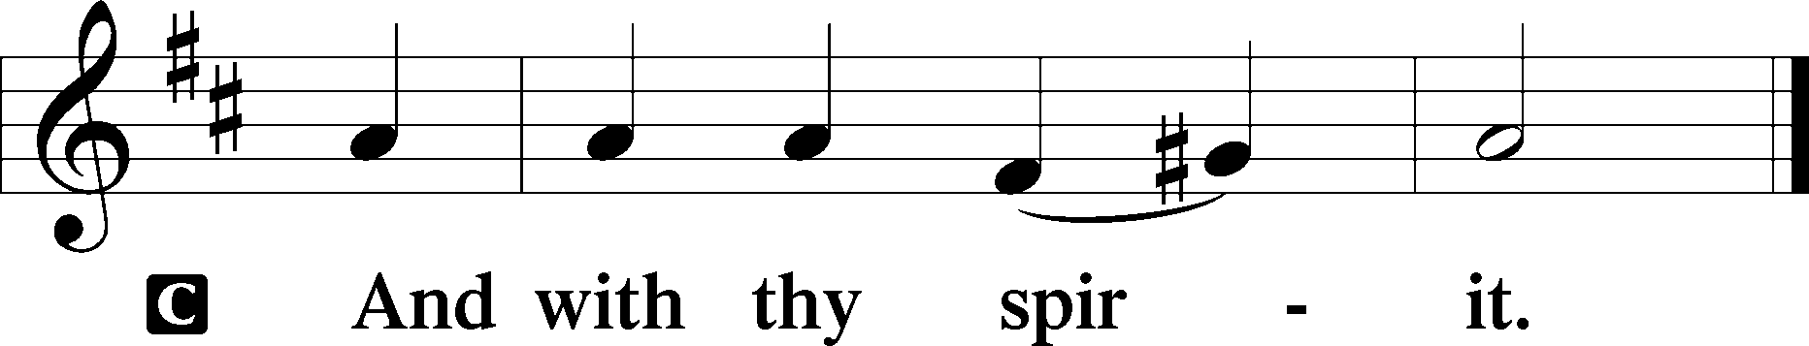

Benedicamus LSB 202
A Bless we the Lord.

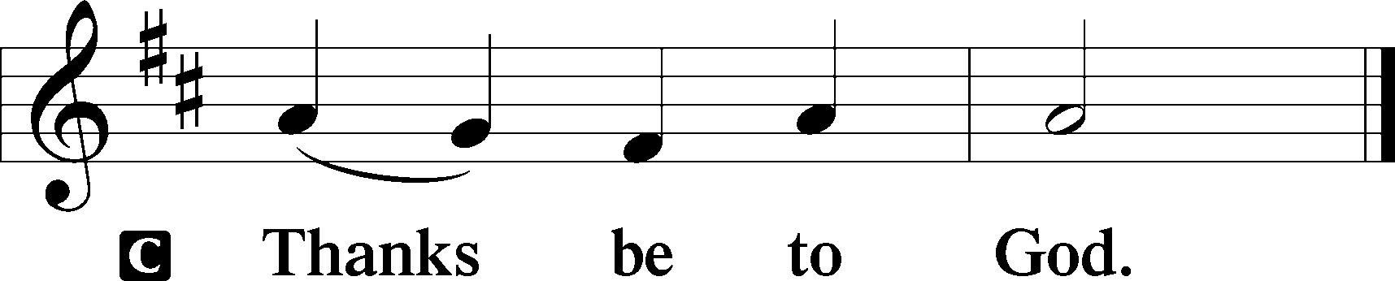

Benediction LSB 202
P The Lord bless you and keep you.
The Lord make His face shine upon you and be gracious unto you.
The Lord lift up His countenance upon you and T give you peace.
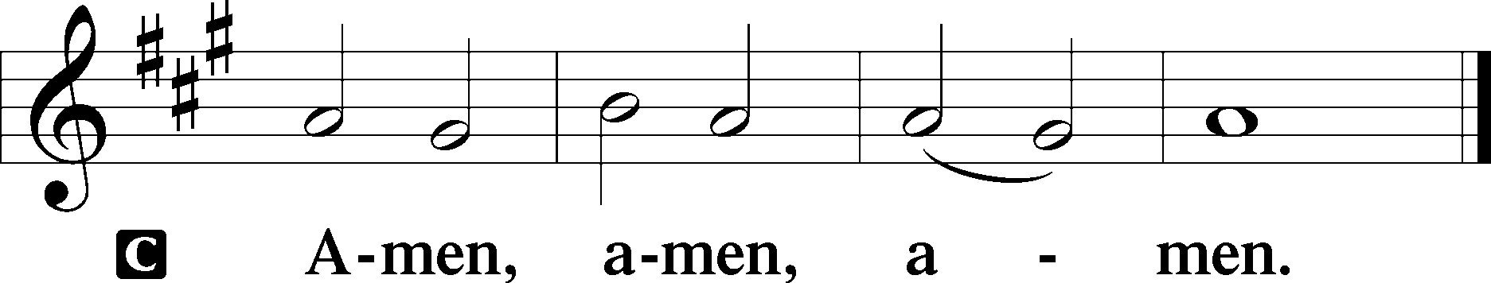

Closing Hymn
477 Alleluia, Alleluia! Hearts to Heaven
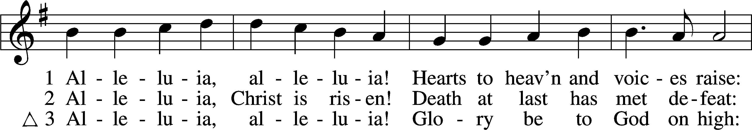
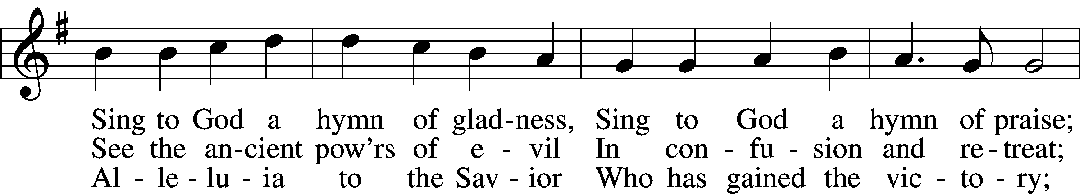
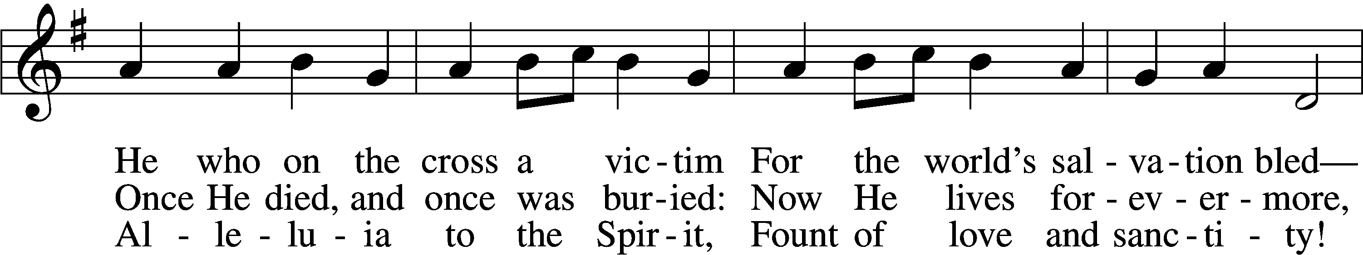
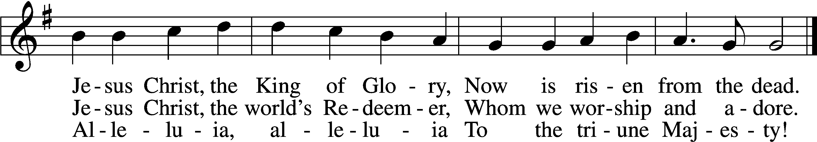
Text (sts. 1, 3): Christopher Wordsworth, 1807–85; (st. 2): rev. The Jubilate Group
Tune: Ludwig van Beethoven, 1770–1827; adapt. Edward Hodges, 1796–1867
Text (st. 2): © 1982 The Jubilate Group, admin. Hope Publishing Co. Used by permission: LSB Hymn License no. 110002874
Text (sts. 1, 3) and tune: Public domain

Gideons Presentation

Acknowledgments
Divine Service, Setting Three from Lutheran Service Book
Unless otherwise indicated, Scripture quotations are from the ESV® Bible (The Holy Bible, English Standard Version®), copyright © 2001 by Crossway, a publishing ministry of Good News Publishers. Used by permission. All rights reserved.
Created by Lutheran Service Builder © 2024 Concordia Publishing House.

